Jennifer DeVore

10 March 2020

CIS 435

**Unit 2 Graded Exercise 3: Coding Subqueries**

1. Write a SELECT statement that returns the same result set as this SELECT statement. Substitute a subquery in a WHERE clause for the inner join.

SELECT DISTINCT VendorName FROM Vendors JOIN Invoices

ON Vendors.VendorID = Invoices.VendorID ORDER BY VendorName;

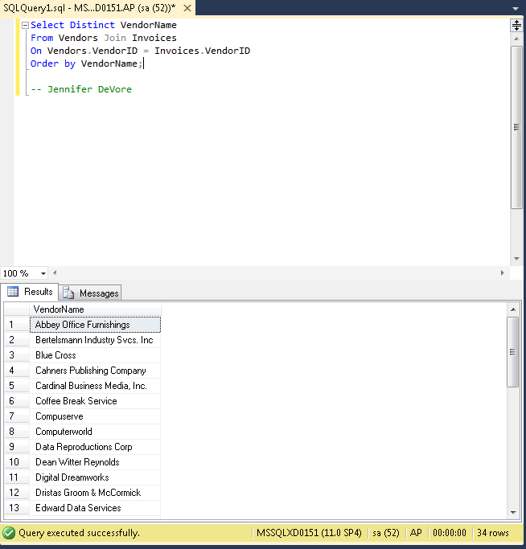

1. Write a SELECT statement that answers this question: Which invoices have a PaymentTotal that’s greater than the average PaymentTotal for all paid invoices? Return the InvoiceNumber and InvoiceTotal for each invoice.

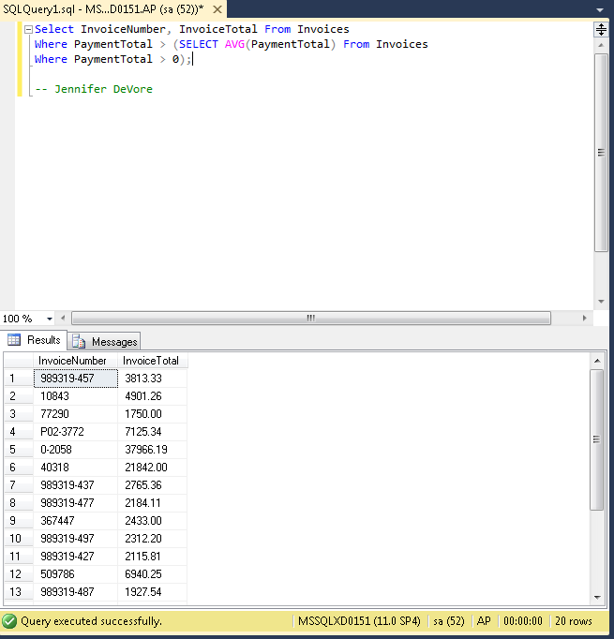

1. Write a SELECT statement that answers this question: Which invoices have a PaymentTotal that’s greater than the median PaymentTotal for all paid invoices? (The median marks the midpoint in a set of values; an equal number of values lie above and below it.) Return the InvoiceNumber and InvoiceTotal for each invoice. Hint: Begin with the solution to exercise 2, then use the ALL keyword in the WHERE clause and code “TOP 50 PERCENT PaymentTotal” in the subquery.

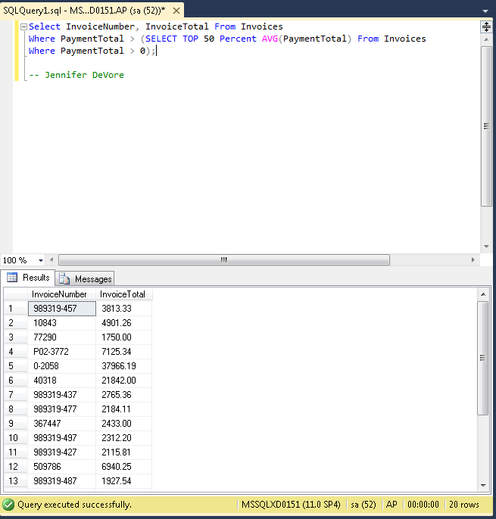

1. Write a SELECT statement that returns two columns from the GLAccounts table: AccountNo and AccountDescription. The result set should have one row for each account number that has never been used. Use a correlated subquery introduced with the NOT EXISTS operator. Sort the final result set by AccountNo.

